**Integrating Jenkins with Terraform using Azure**

Firstly, we need to have terraform to be installed for that installation steps refer the terraform installation document.

Install Jenkins in root directory of terraform using some commands

Switch into root sudo su – Update it apt update

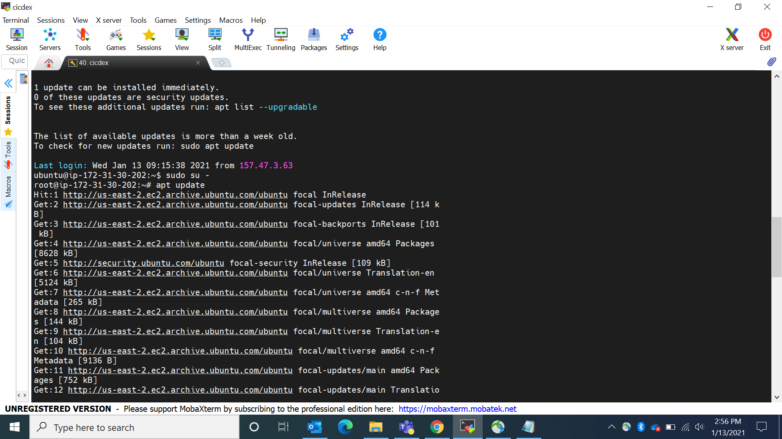

SET UP THE REPOSITORY

Update the apt package index and install packages to allow apt to use a repository over HTTPS:

sudo apt-get install \

apt-transport-https \

ca-certificates \

curl \

gnupg-agent \

software-properties-common

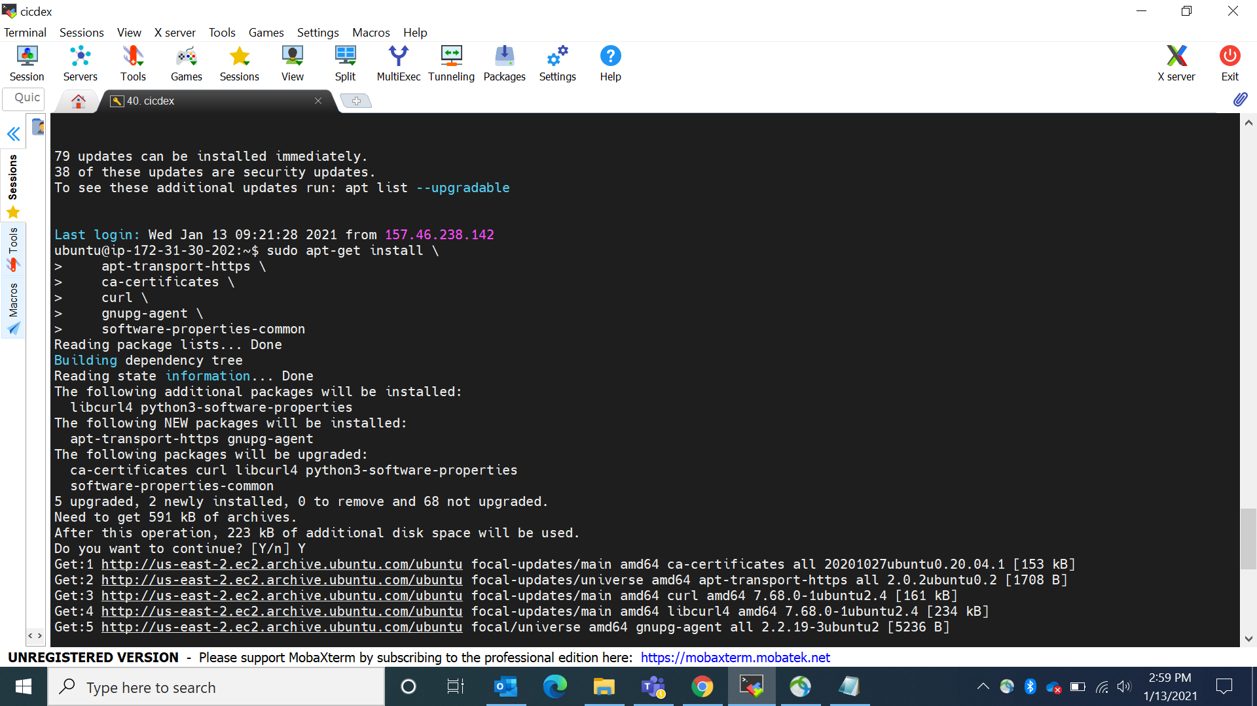

Add Docker’s official GPG key:

curl -fsSL https://download.docker.com/linux/ubuntu/gpg | sudo apt-key add -

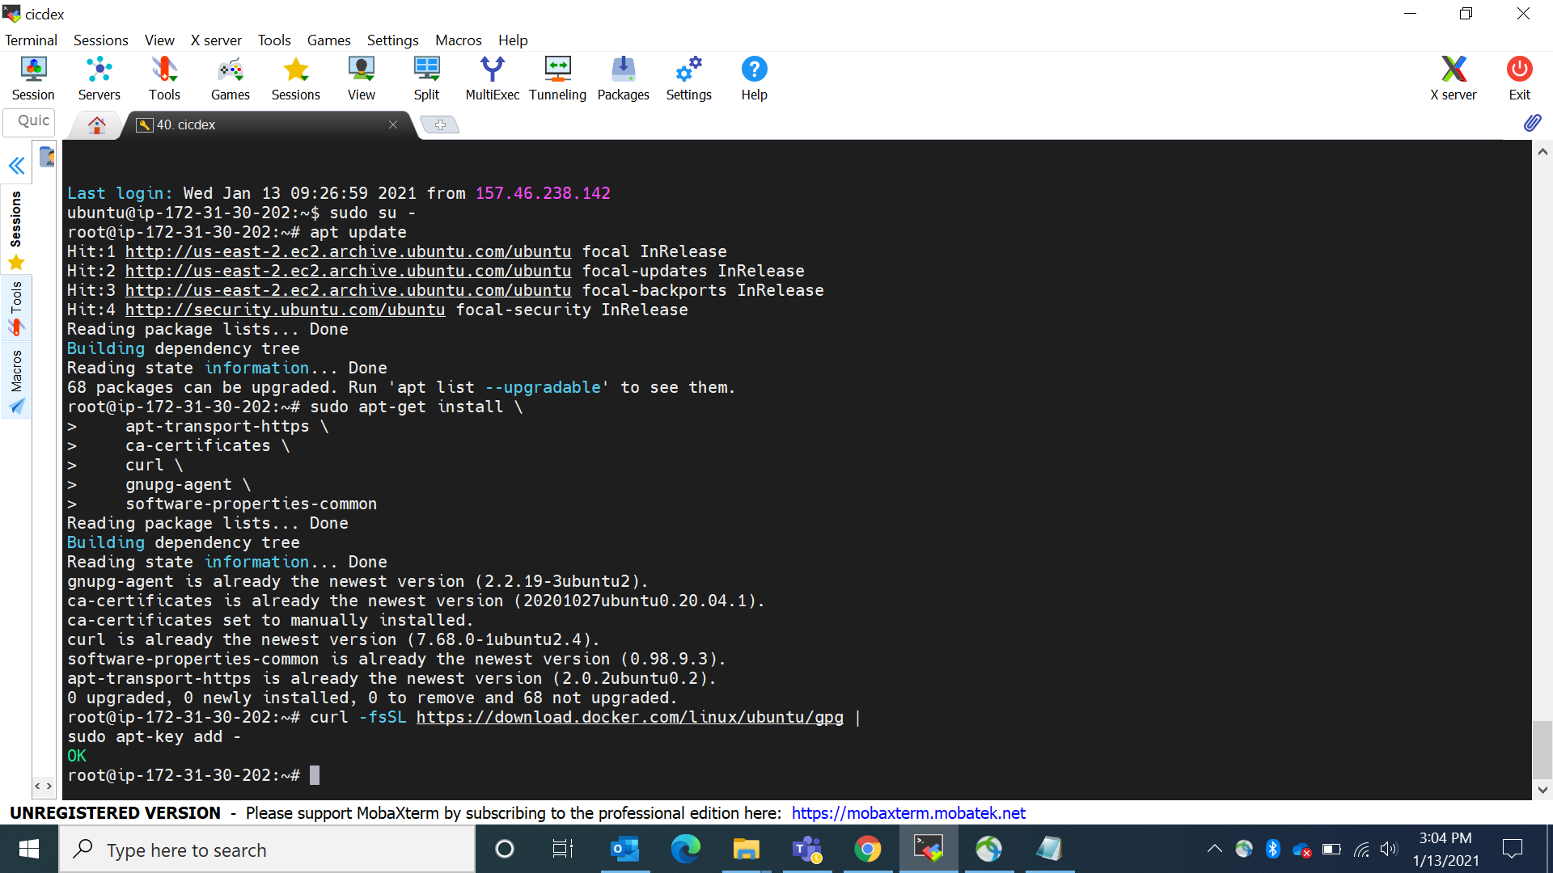

Verify that you now have the key with the fingerprint

sudo apt-key fingerprint 0EBFCD88

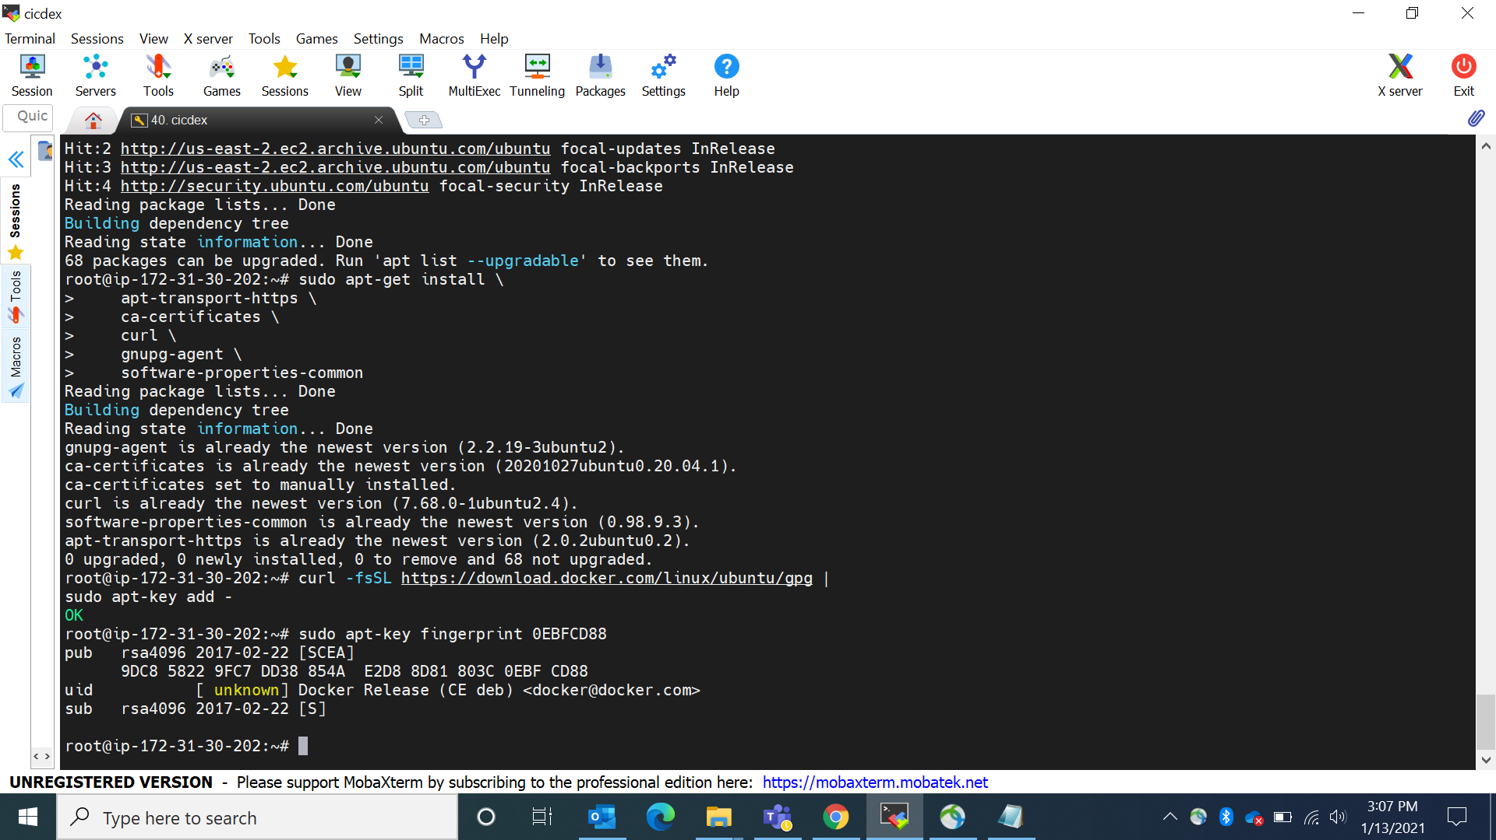

Check as sudo apt-get update

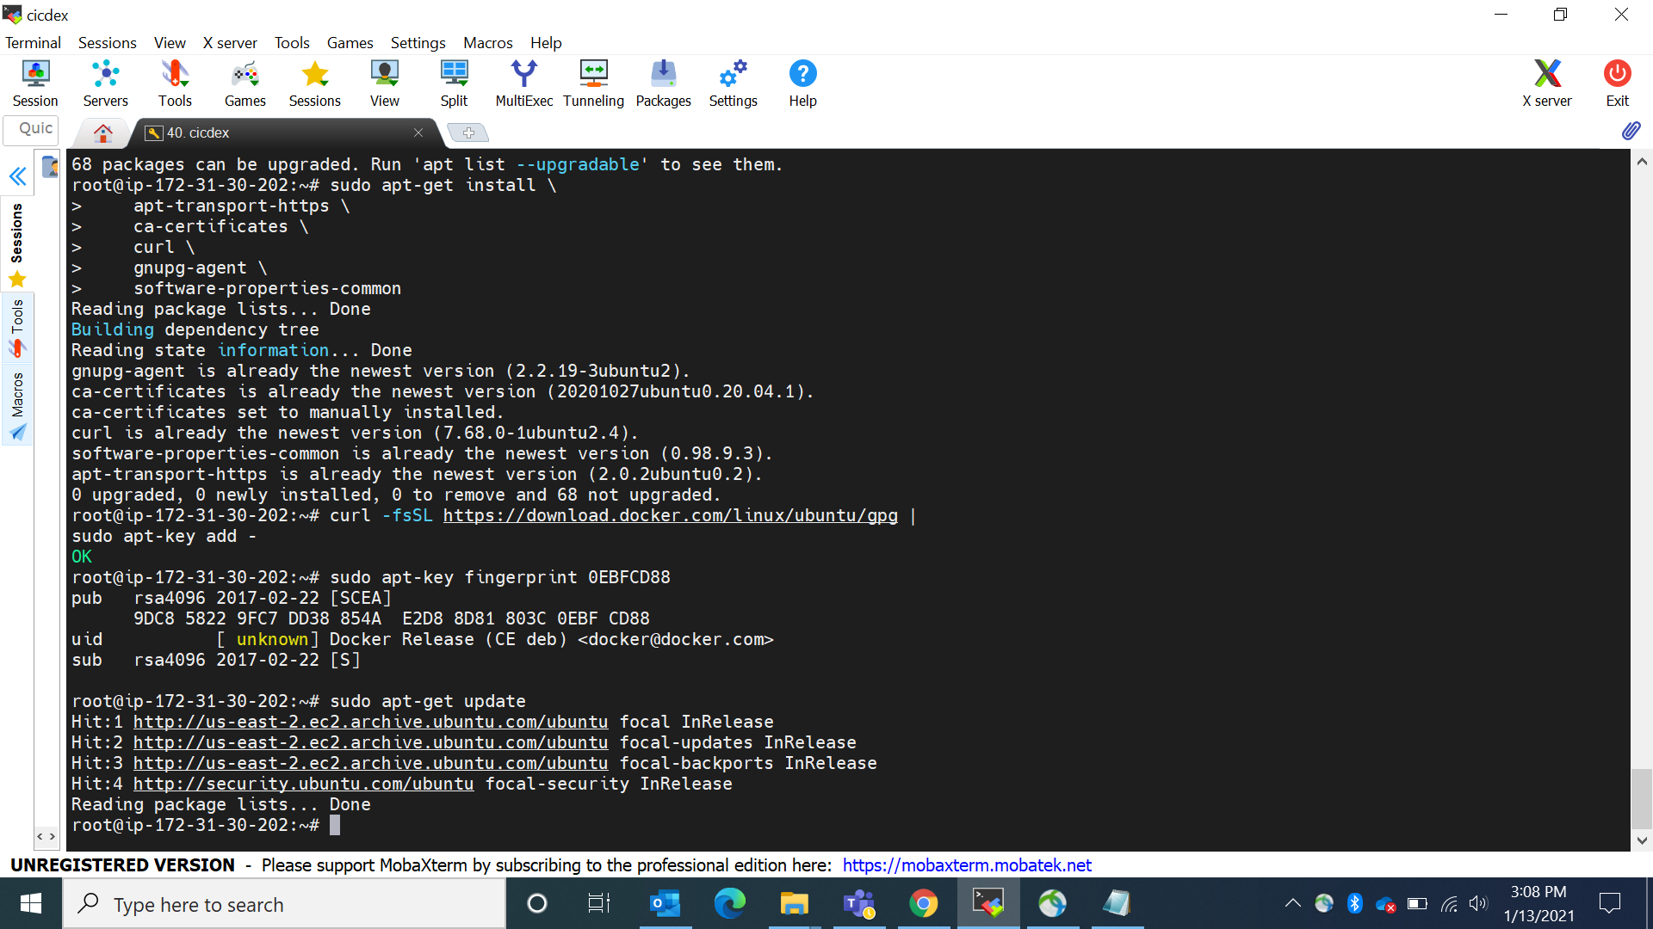

Use the following command to set up the **stable** repository.

sudo add-apt-repository \

"deb [arch=amd64] https://download.docker.com/linux/ubuntu \

$(lsb_release -cs) \

stable"

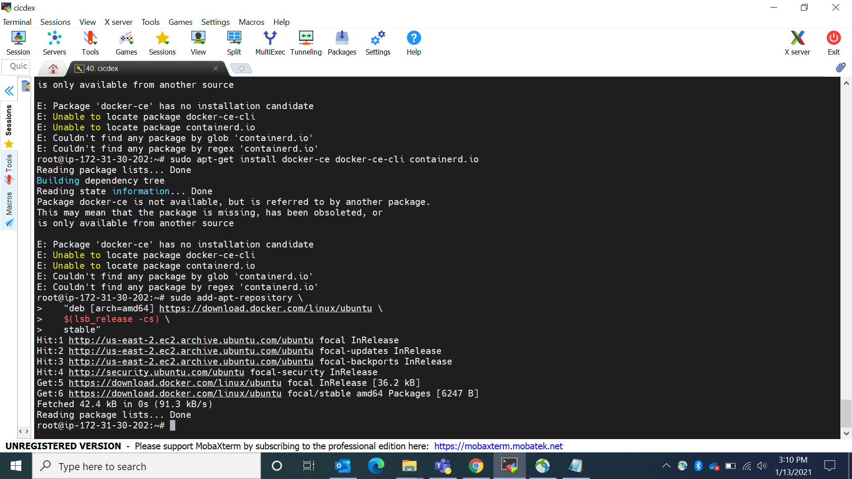

docker volume create jenkinsvol (or creating the docuker voulme)

docker run -u root -d --name myjenkins_server -p 9080:8080 -p 9096:9096 -v

jenkinsvol:/var/Jenkins_home/workspace jenkins/jenkins:lts

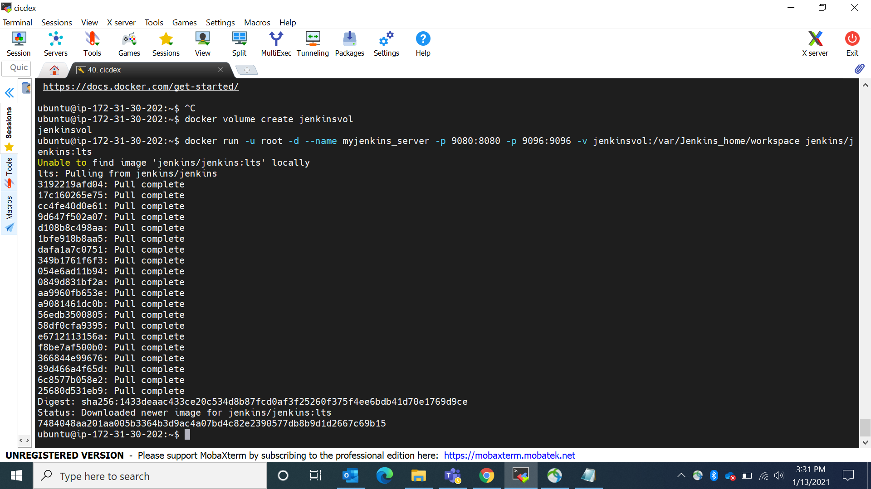

To Know the ip address to setup the jenkins

curl ipconfig.io

for getting the initial admin pwd

go to

docker exec -it myjenkins_server /bin/bash

cat /var/jenkins_home/secrets/initialAdminPassword

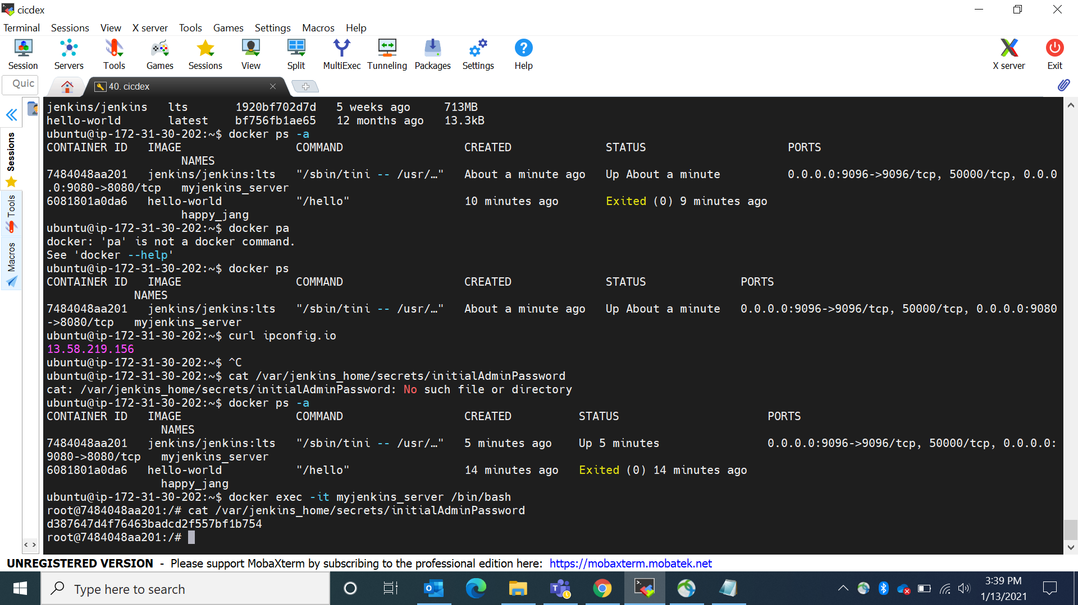

docker start myjenkins_server (to start the jenkins in root directory)

Now open the jenkins portal using the ip configuration and port number

Ip cofiguration:9080

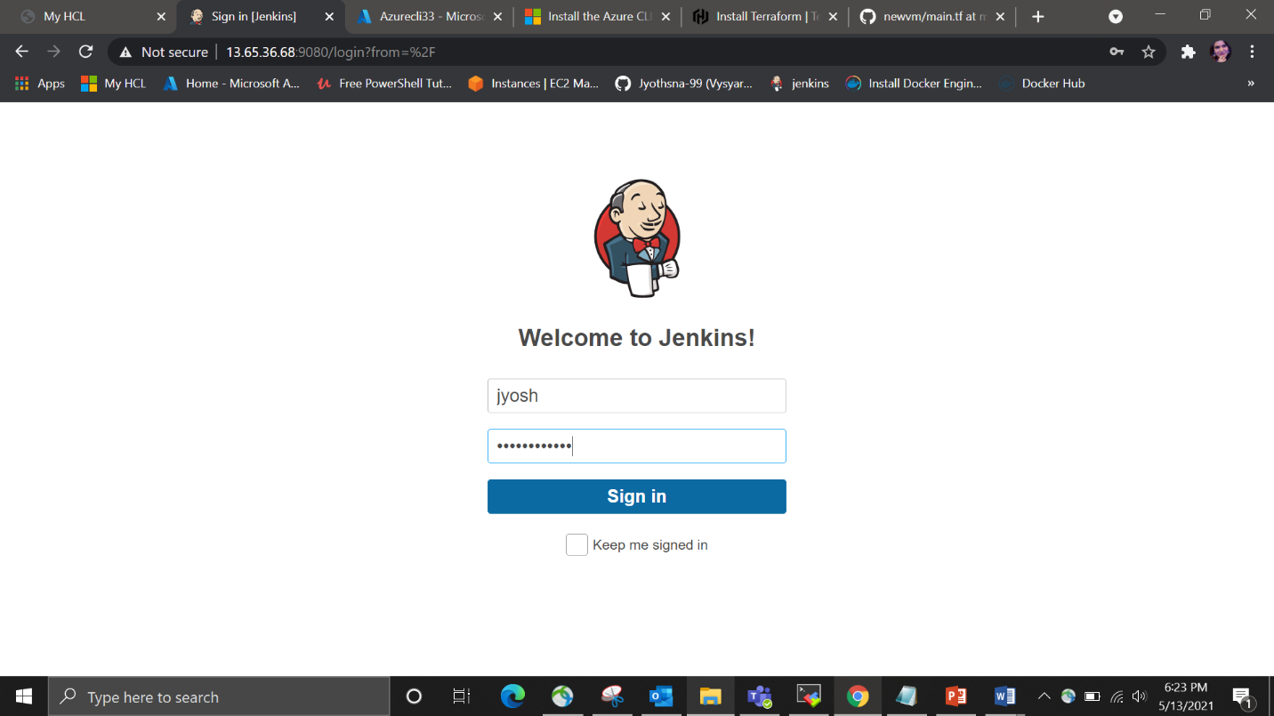

Now install terraform inside the Jenkins workspace

After entering into workspace now install terraform

docker exec -it myjenkins_server /bin/bash

cd var/jenkins_home

cd workspace (this is to enter the workspace to install the terraform init)

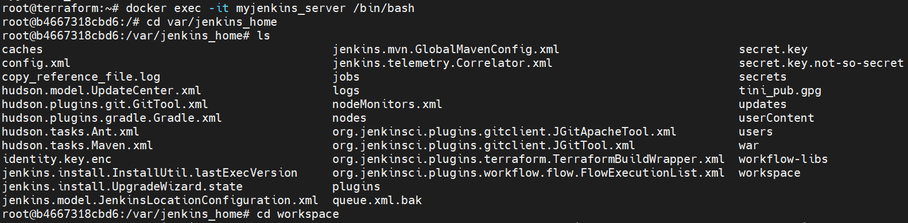

sudo apt-get update

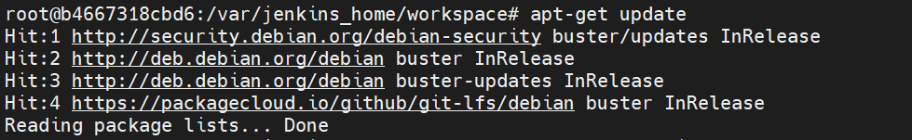

apt-get install -y gnupg software-properties-common curl

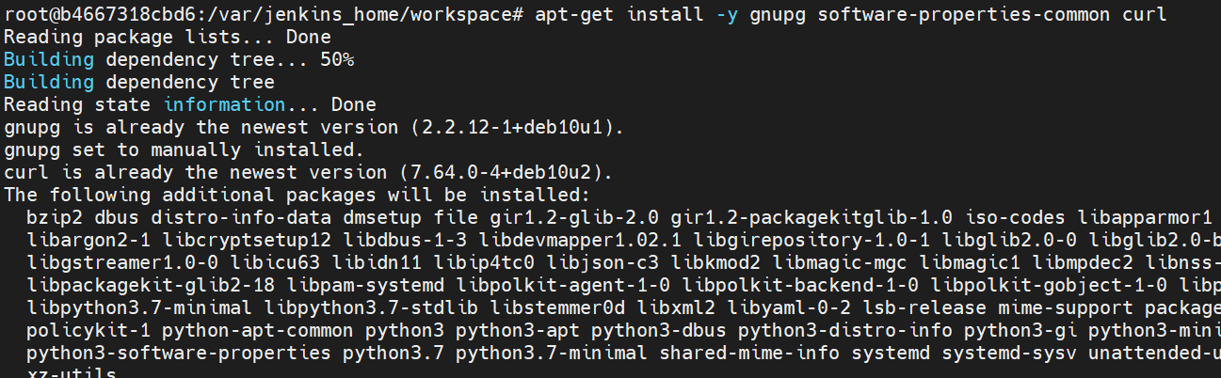

Add the HashiCorp [GPG key](https://apt.releases.hashicorp.com/gpg).

curl -fsSL https://apt.releases.hashicorp.com/gpg | apt-key add –



Add the official HashiCorp Linux repository.

apt-add-repository "deb [arch=amd64] https://apt.releases.hashicorp.com $(lsb_release -cs) main"



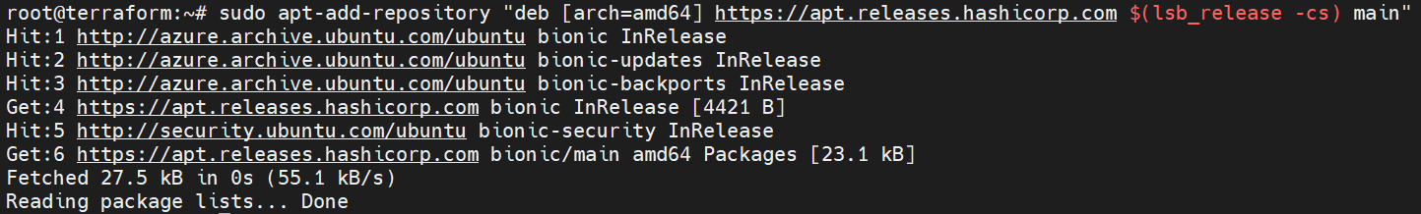

Update to add the repository, and install the Terraform CLI.

apt-get update && apt-get install terraform

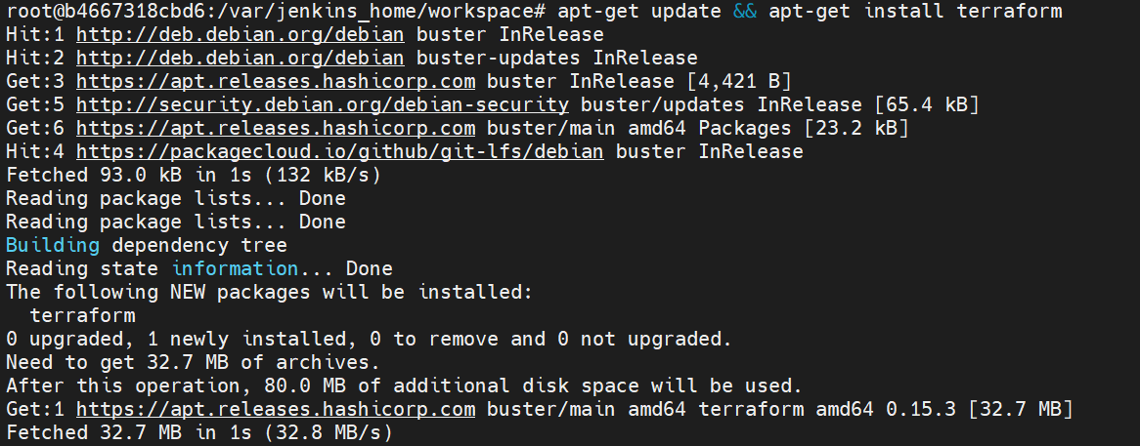

terraform version

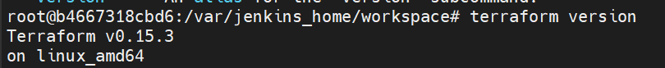

Install azureCLI

curl -sL <https://aka.ms/InstallAzureCLIDeb> | bash

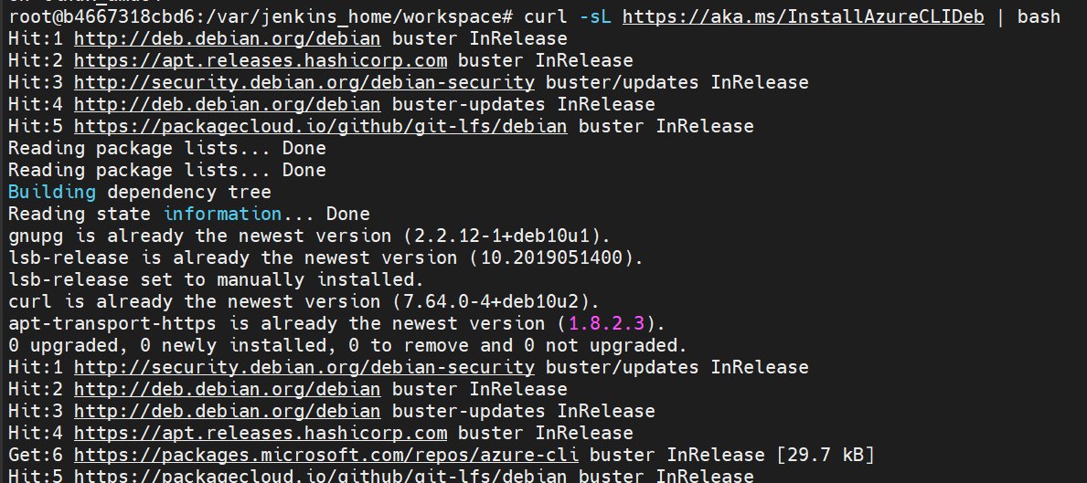

Now login with azure

az login

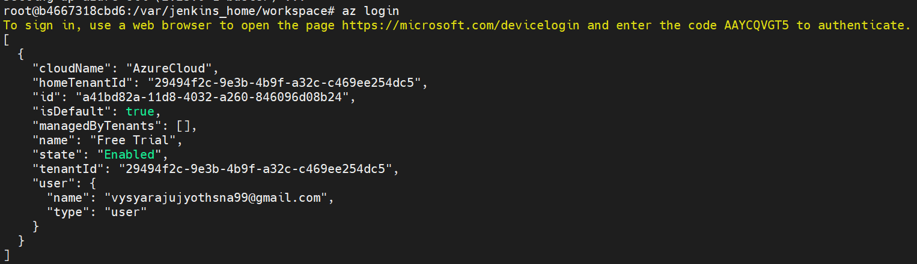

Open that website in goggle and give that code and select your azure account mail account

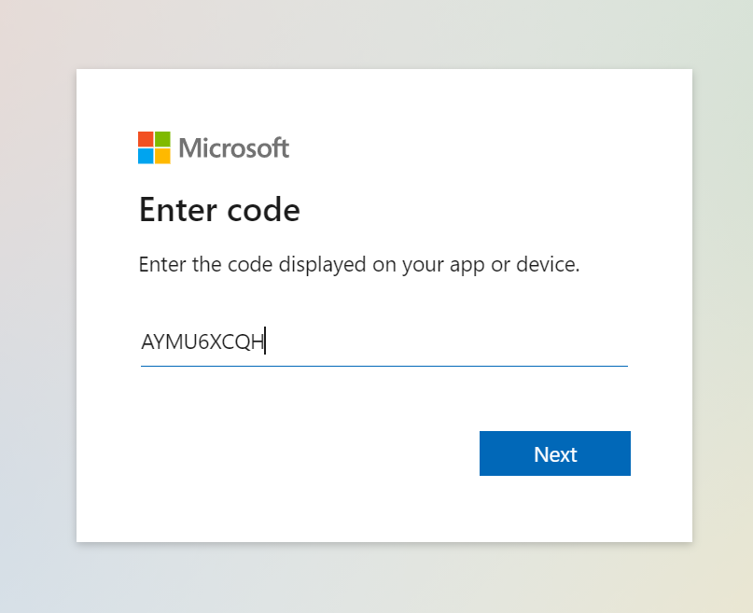

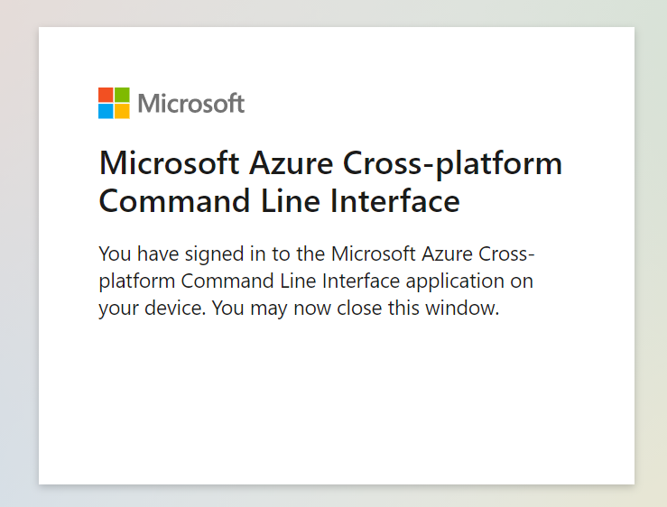

Now create a new pipeline script in Jenkins tool

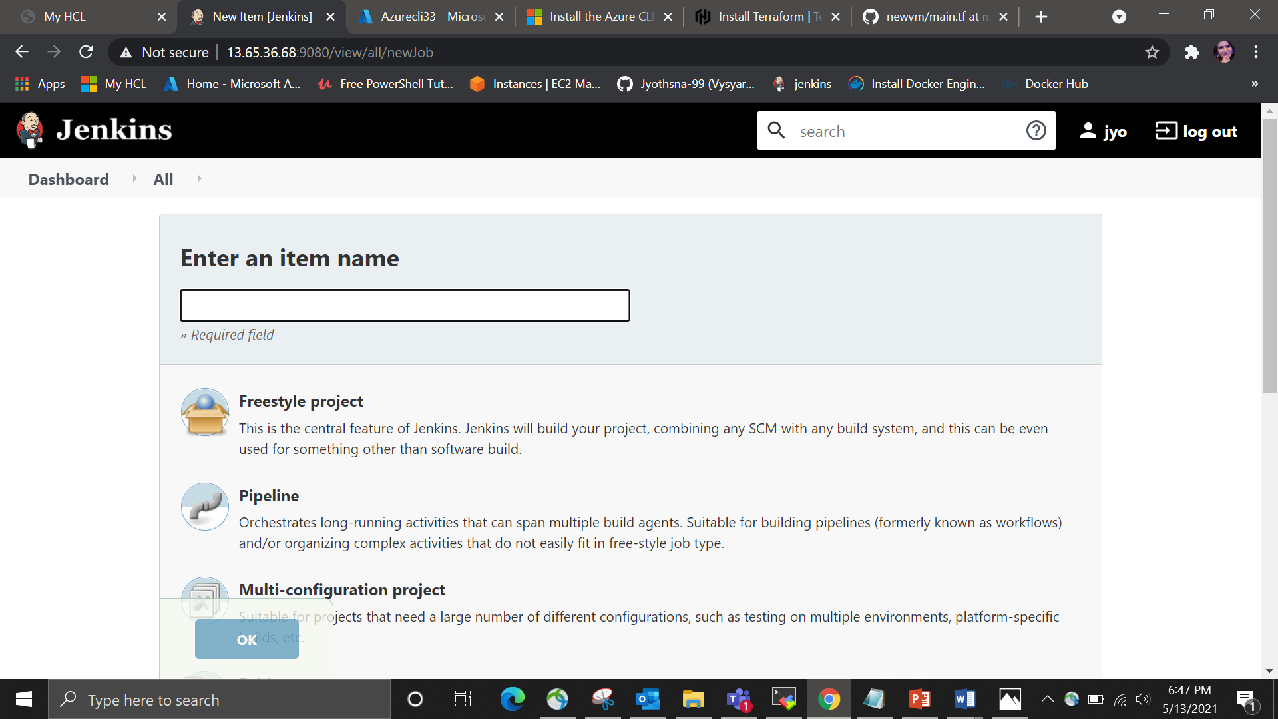

Install terraform plugin in manage plugins

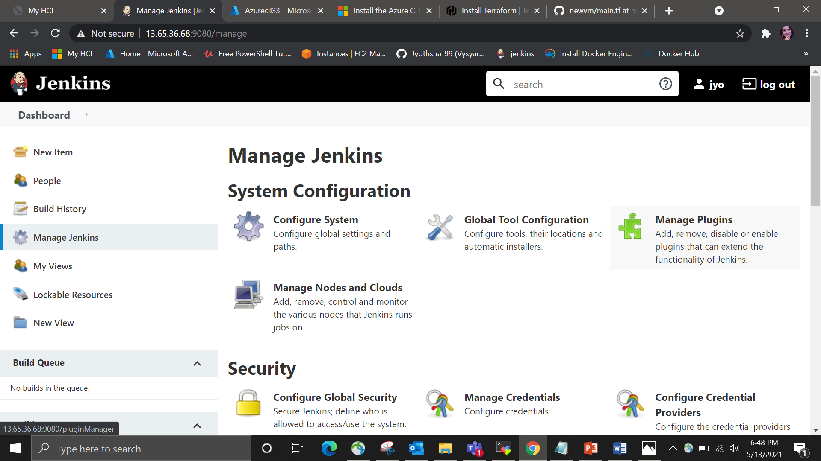

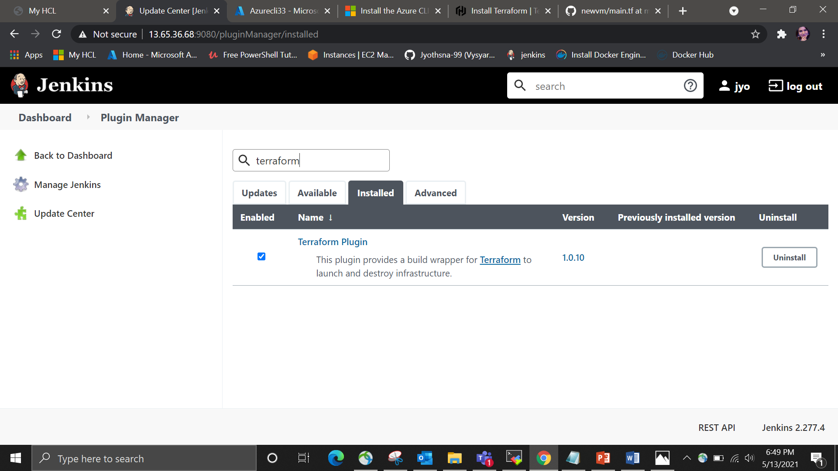

Configure the terraform plugin in global tool configurations

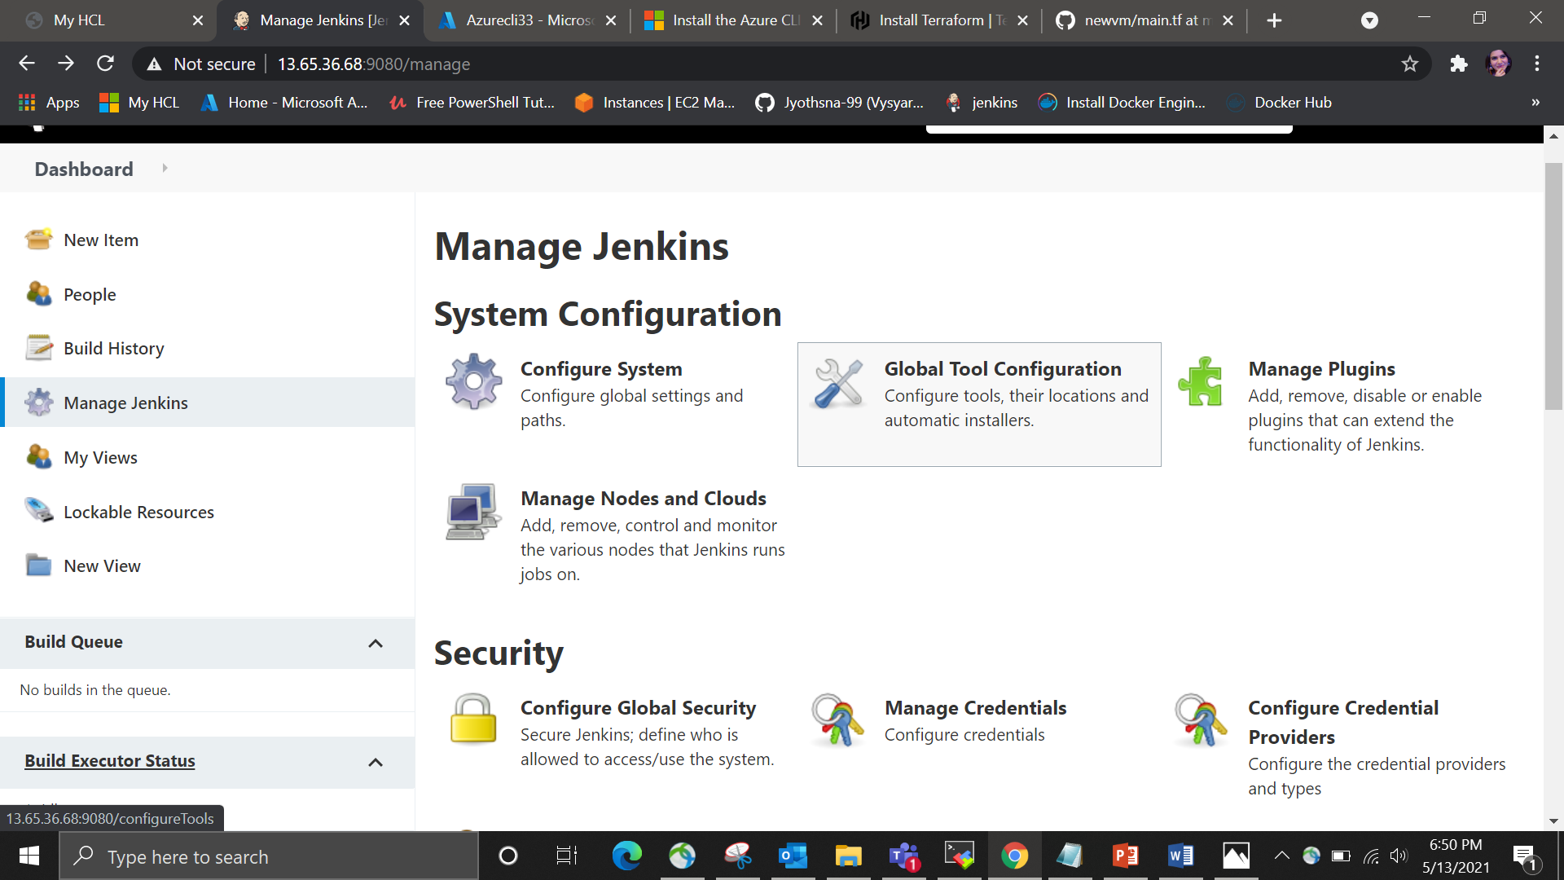

Name as terraform which is present in your directory (/usr/bin)



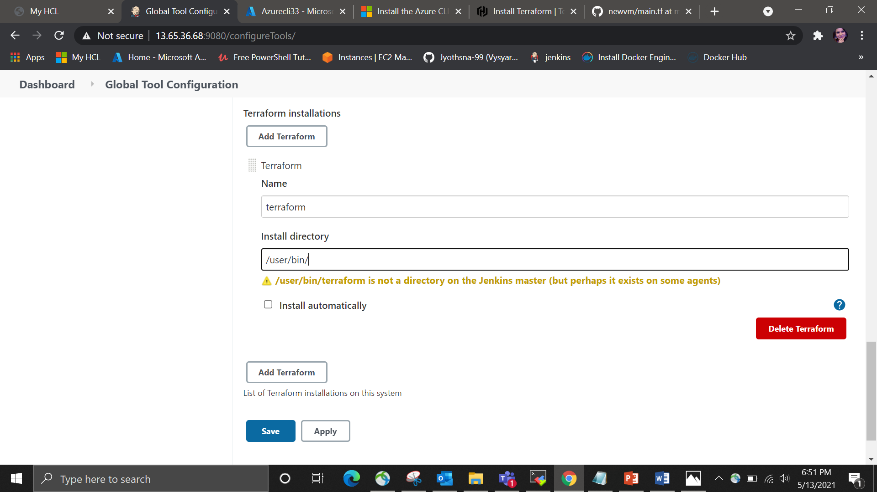

Write the pipeline script

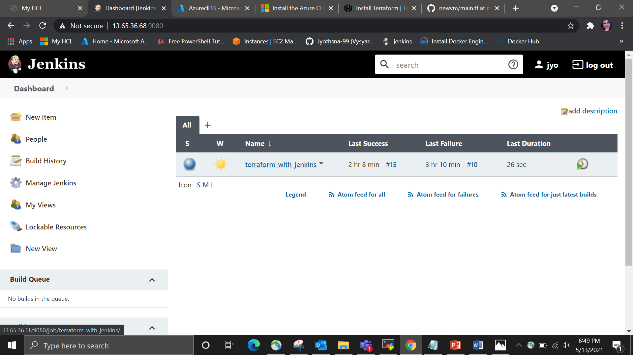

pipeline {

agent any

stages {

stage('Hello') {

steps {

echo 'Hello World'

}

}

stage('checkout') {

steps {

git '<https://github.com/GKasiraju/newvm.git>’

}

}

stage('terraform init') {

steps {

sh 'terraform init'

}

}

stage('terraform validate') {

steps {

sh 'terraform validate'

}

}

stage('terraform plan') {

steps {

sh 'terraform plan -var "admin_username=kasiraju" -var "admin_password=Ubuntu@12345'

}

}

stage('terraform apply' ){

steps{

sh 'terraform apply --auto-approve -var "admin_username= kasiraju " -var "admin_password= Ubuntu@12345"'

}

}

// stage('terraform destroy' ){

// steps{

// sh 'terraform destroy --auto-approve'

// }

// }

}

}

In that git url we are maintaining the declarative configuration file i.e. main.tf

Which has entire script to create a virtual machine and resource group

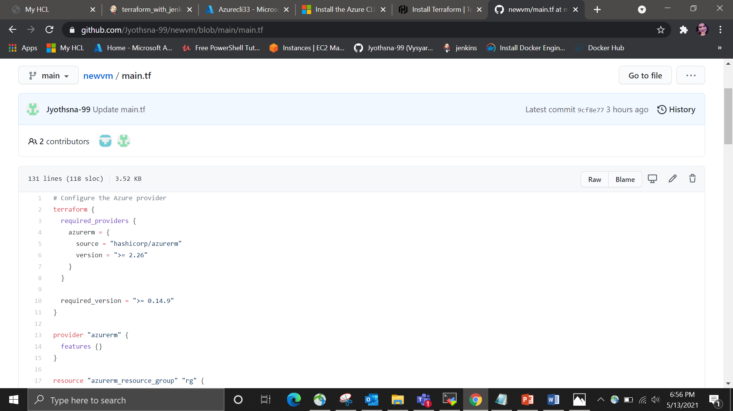 Now build your pipeline script

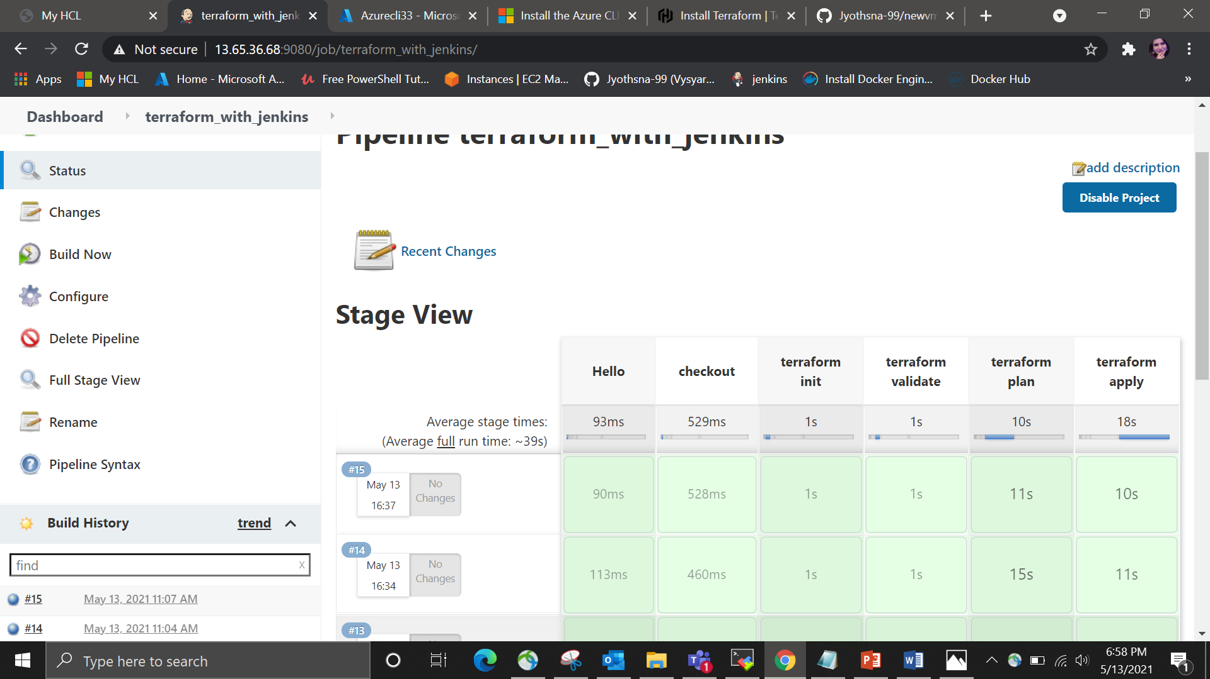

Now go to azure portal and check for the resource group that you created

